**Capstone Project Battle of the Neighborhood**

**Josephine Matignas**

**Filipino Food in New York City**

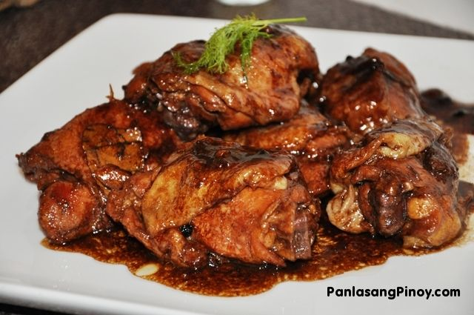

I. **Introduction**

**Background**

Filipino dishes are rich in flavors. It like when you taste it there’s a lot of things happening inside your mouth. As Philippines was conquered by few races that adds the variety and taste on the Filipino dishes. Even though the country itself is so small there’s a big list on how to cook a dish. Its because there are lots of island and different places has their own special dish. Growing up food is life and if Mexico has tortilla in their table Filipino has white rice. We cant eat without white rice. We also have exotic food specially in places near the mountains. You cant go wrong with Filipino food.

**Problem**

Living in the US have its downside. Its hard to find an authentic Filipino food place. Thinking to put up a Filipino food place is a dream. In this analysis we will try to answer the main question Where is the best Filipino Restaurant in New York City? Is this near each other or scattered all over New York. This project will determine the best places to go to find the best Filipino restaurant for Filipinos like me and for you to try out.

**Audience**

This analysis will be beneficial for the people who is looking to find an authentic taste. And for people who like to invest in the Filipino restaurant.

**Data Acquisition**

All the data use in this analysis is from <https://cocl.us/new_york_dataset>

And <https://data.cityofnewyork.us/City-Government/Borough-Boundaries/tqmj-j8zm> for the neighborhood where the Filipino restaurant are.

Use Foursquare API to gather the places, rating and other data.

**Methodology**

Data collection is form <https://cocl.us/new_york_dataset> . And use Foursquare to locate the address, their address and other data. It will be rank according to its ratings and the neighborhood where is at. At the end will show the map of the venues.

**Result**

Base on the figure there’s not a lot of Filipino restaurant but its enough for us to analyze their rating and where their at.

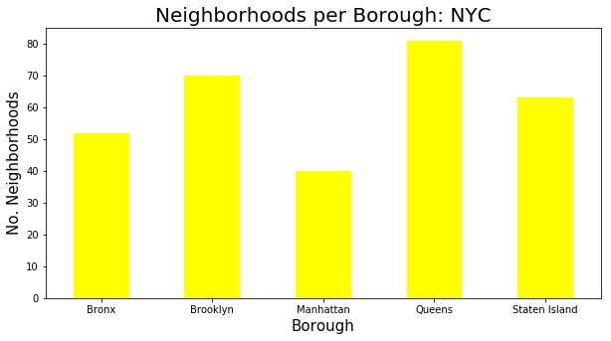

Figure 1. Number of food place and number of neighborhood

Based on the next figure there’s only 19 Filipino restaurant in the entire New York City neighborhood.

Figure 2 Show the tail of the data frame for the Filipino food place.

| **Borough** | **Neighborhood** | **ID** | **Name** |
| --- | --- | --- | --- |
| **14** | Staten Island | **Clifton** | **54c43136498ee8c2a685861e** | **Phil-Am Kusina** |
| **15** | Queens | **Jamaica Hills** | **4c22a0bc9085d13a53af86cc** | **Asian Food Ltd.** |
| **16** | Manhattan | **Stuyvesant Town** | **5a73b1f49ef8ef531a1c08df** | **Mama Fina's** |
| **17** | Manhattan | **Stuyvesant Town** | **503f293c19a9def238a153b3** | **Jeepney Filipino Gastropub** |
| **18** | Queens | **Sunnyside Gardens** | **4aecab47f964a52026ca21e3** | **Tito Rad's Grill & Restaurant** |
|  |  |  |  |  |

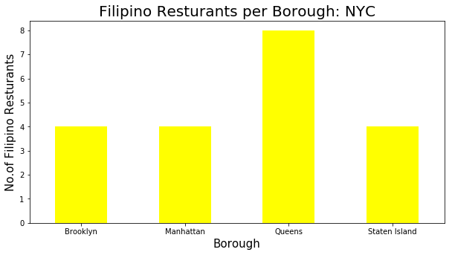

Figure 3 It show there’s only couple of places in a neighborhood.

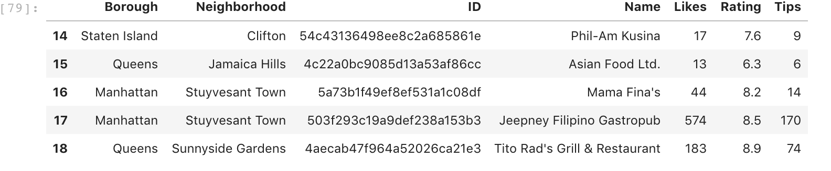

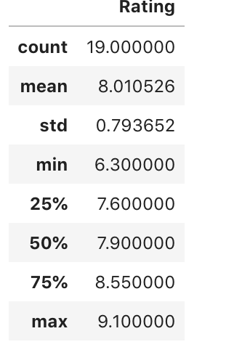

Based of this figure explain the Ratings of all the 19 Filipinos food places in the neighborhood.

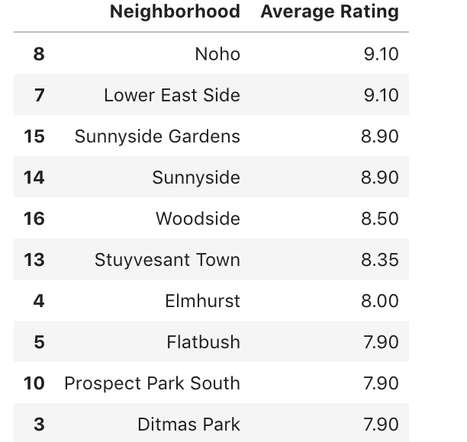

Based on this figure it shows that all the Filipino food places has above average ratings in foursquare.

Figure 7. You can see there not a lot of places and it scattered.

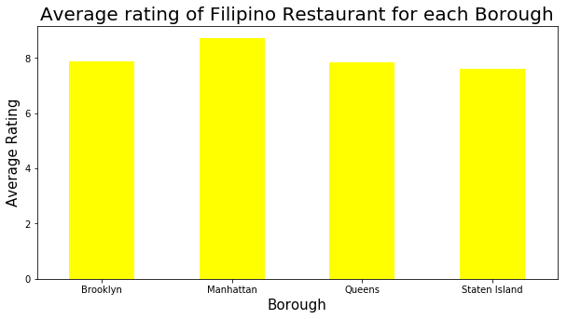

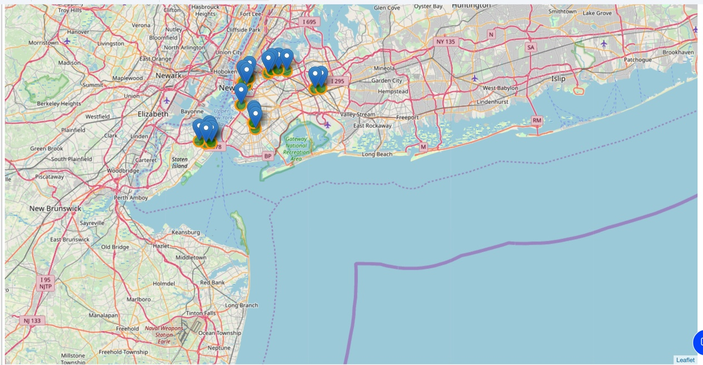

**Conclusion**

Based on the figures and analysis there’s not enough Filipino food place in New York City Neighborhood. And even though there’s only several places there likes and ratings are above average. It concludes that people likes the Filipino dishes and even there’s not a lot people go visit those places and they are happy and satisfied. It only shows that there’s a good possibility that investing in Filipino restaurant is a good path to take.